Article Sammary of Promotion

Hiroto Hoshino

◯Advertisement

→In point of whole game industry view, the advertisement cost is paid about 226.5 million dollars, so the promotion is the big factor in the market.

→Microsoft spent about 34.7 million dollars in promotion such as TV commercial.

→The following graph indicates the details of the advertisement cost.

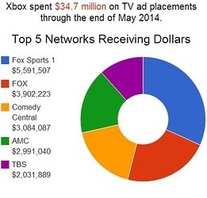

→The Xbox TV commercial named “All in One” seems most effective, and is played about 1300 times.

→This commercial costs about 12.1 million dollars, so it is also most expensive in the whole commercials.

→The investigation of TV promotion cost which the company named “iSport” published in 2013 ranked Xbox in the first place.

<Reference>

Game Park (2014). The TV advertisement cost in the field of game industry is already more than 226.5 million. *Gamegyokainokoukokuhihasudeni2oku2650manyenwotoppa.* Accessed on <https://www.gamespark.jp/article/2014/06/30/49717.html>